NAME:
TOPIC

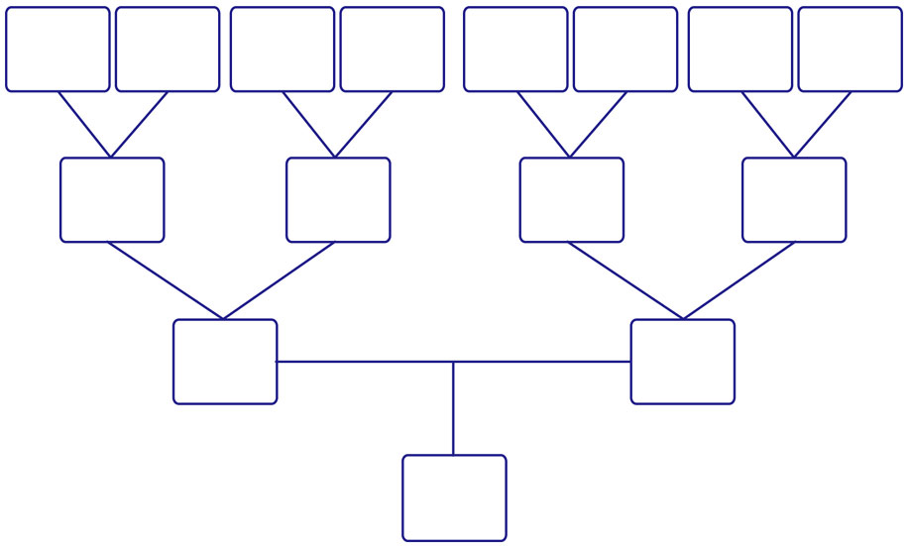
text
text
text
text
text
text
text
text
text
text
text
text
text
text
text

